The Effects of Energy Drink Consumption on the Brain and Pancreas of Adult Male Albino Rats: A Biochemical and Histopathological Study
Amira M. Samir, Abeer A.I. Sharaf El-Din, Maha Mohamed Mokhtar, Marwa M. M. Fawzy, Noha Elnajjar
Forensic Medicine and Clinical Toxicology Department, Faculty of Medicine, Benha University, Benha, Egypt
Abstract: Energy drinks (EDs) are carbonated beverages containing caffeine, sugars, taurine, and herbal extracts. Their consumption has markedly increased worldwide, particularly among young individuals despite growing evidence of serious multisystem health risks. Aim: This study aimed to investigate the potential adverse effects of one of the popular EDs in Egypt at both low and high doses on the brain and pancreas of adult male albino rats through biochemical and histopathological studies. Materials and Methods: Thirty adult male albino Wistar rats (8 weeks old) were randomly divided into three groups (10 rats each). Group I served as the control group, while groups II and III received Volt ED at doses of 3.1 mL/100 g/day and 6.3 mL/100 g/day, respectively, administered orally by gavage. Ethical approval was obtained from the Research Ethics Committee, Faculty of Medicine, Benha University. Serum glucose, brain neurotransmitters (GABA and dopamine), malondialdehyde (MDA), and catalase (CAT) in brain and pancreatic tissue homogenates were measured. Histopathological examinations of both organs were also performed. Results: ED administration significantly increased serum glucose and induced dose-dependent reductions in brain GABA and dopamine concentrations. Oxidative stress was evident by elevated MDA and reduced catalase activity in brain and pancreatic tissues. Histopathological findings revealed neuronal degeneration and hemorrhage in the brain, along with pancreatic necrosis and fibrosis. Conclusion: ED overconsumption induces hyperglycemia, neurotransmitter depletion, oxidative stress, and tissue damage in brain and pancreas, warranting caution regarding their consumption
Keywords: Energy Drinks, Oxidative Stress, Neurotransmitters, Brain toxicity, pancreas, Rats.

Introduction:
In recent years, the consumption of energy drinks (EDs), particularly by young adults and adolescents, has risen significantly. These beverages are often marketed with claims that they can increase concentration, boost energy levels, and improve mood. However, concerns have been raised about the health risks associated with excessive consumption (Costantino et al., 2023).
EDs are carbonated beverages that contain caffeine, taurine, glucose, fructose, glucuronolactone, vitamins, and other herbal extracts such as guarana and ginseng. Guarana and ginseng are natural sources of caffeine, and their levels are often not labeled on the packaging (Górka et al., 2025).
Caffeine is a primary component of EDs, and recent research has found that the components of EDs may exert synergistic effects rather than acting through caffeine alone. Most EDs contain 32 mg of caffeine per 100 mL which exceeds the Food and Drug Administration (FDA) imposed limit of 20 mg of caffeine per 100 mL of traditional soda (Hassan et al., 2023). Also, the daily exposure to taurine, gluconolactone, and glucuronolactone from EDs in younger populations is considered high. Additionally, the high sugar content, which forms 10-13% of the volume of EDs, contributes to diabetes and obesity (Boyina and Dodoala, 2020).
The consumption of EDs is associated with numerous adverse effects, including neurological symptoms such as tremors and nervousness; cardiac issues such as tachycardia and chest pain; gastrointestinal symptoms; hematological disorders; kidney problems; hepatitis; and pancreatitis (Abdelwahab et al., 2020).
Evaluating the effects of food additives, such as taurine and other amino acids, on mood and behavior in adults is of growing concern (Boyina and Dodoala, 2020). The brain is one of the most vulnerable organs to toxicity, as these substances can affect neuronal functions and the concentration of catecholamines in the brain, which are linked to Parkinson's disease, cognitive dysfunction, and neuropsychiatric disorders (Abdel-Kareem et al., 2023).
Beyond neurological effects, ED consumption has also been implicated in metabolic disorders. Type 2 diabetes mellitus is one of the fastest-growing public health problems worldwide. The consumption of sugar-sweetened beverages has been proven to be associated with adverse health consequences in the diabetic population and is also linked to a high risk of diabetes, obesity, and metabolic syndrome in healthy individuals (Tseng et al., 2021).
In Egypt, the consumption of EDs among youth is still underestimated and represents a significant public health challenge. The production and consumption of EDs in Egypt are increasing yearly, with a lack of knowledge about their health hazards (Hafez et al., 2023).
Materials and methods:
Animals:
The study included 30 adult male albino rats (weighing 130 – 150 g), aged 8 weeks. Rats were housed at the Animal Breeding Unit, Faculty of Veterinary Medicine, Benha University, and acclimatized for one week under standardized conditions with free access to food and water. according to Cuschieri and Baker (1977).

Chemicals:
Commercially available ED (Volt®, AJE Company, Egypt, 300 mL bottle) was purchased from the local Egyptian market.

Experimental design and animal grouping:
Animals were randomly assigned to three groups (n=10 each):
Group I (control group): 10 rats had unrestricted access to food and purified water, and were kept untreated to serve as baseline controls.
Group II (low-dose ED group): 10 rats (all were given 3.1ml/100 g/day volt ED administered via gavage tube and then sacrificed after four weeks according to Akande and Banjoko (2011).
Group III (high-dose ED group): 10 rats received 6.3 ml/100 g/day of volt ED by gavage tube and then sacrificed after four weeks according to Akande and Banjoko (2011).
Ethical consideration:
The study adhered to the guidelines for the use and care of experimental animals. The research was submitted to the Research Ethics Committee of Benha University's Faculty of Medicine and received approval under approval code (MS-15-7-2024). After completion of specimen collection, humane euthanasia was performed via diethyl ether inhalation, consistent with institutional ethical guidelines. All carcasses were incinerated for proper disposal.
Collection of Samples
Live animals were anesthetized by diethyl ether inhalation in a glass cage then sacrificed by cervical decapitation for taking blood and tissue samples. Blood samples (5 ml) were collected, by puncture of retro-orbital plexus, without anticoagulant for separation of clear serum for biochemical analysis according to Parasuraman et al. (2010).The brain and pancreas were excised, weighed, and cleared of residual blood. Each organ was divided into two equal parts: one half was used for biochemical analysis (homogenate preparation) according to Owolabi et al. (2017), and the other half was fixed in 10% neutral buffered formalin for Histopathological examination (Bancroft and Gamble, 2008).
Studied Parameters
All experimental groups were subjected to biochemical analysis, including serum glucose measurement, estimation of neurotransmitters (GABA and dopamine) in brain tissue homogenates, and evaluation of oxidative stress and antioxidant markers (MDA and CAT) in both brain and pancreatic tissue homogenates; in addition, histopathological examinations were performed on brain and pancreas specimens to assess structural changes induced by the experimental intervention.
Biochemical Analysis
Measurement of Serum Glucose Level:
Blood samples were centrifuged to separate serum, and glucose levels were determined using the glucose oxidase–peroxidase (GOD-POD) method. This assay is based on enzymatic oxidation of glucose with subsequent colorimetric detection of the formed chromogen according to the manufacturer’s instructions (Trinder, 1969).
Estimation of GABA and Dopamine in Brain Homogenates:
Brain GABA and dopamine levels were determined using a rat-specific ELISA kit. The assay is based on an HRP-conjugated enzymatic colorimetric reaction measured spectrophotometrically at 450 nm (Engvall and Perlmann, 1971).
Estimation of Oxidative Stress and Antioxidant Markers:
Malondialdehyde (MDA) and catalase (CAT) enzyme levels in brain and pancreatic homogenates were measured using a rat-specific ELISA kit. The assay is based on an enzyme-linked colorimetric reaction, and absorbance was read at 450 nm using a microplate reader (Engvall and Perlmann, 1971).
Histopathological Examination of Brain and Pancreas:
Histopathological examinations of both brain and pancreas were conducted on all experimental rats, and the slides were analyzed at the Pathology Department of the Animal Health Research Institute, Zagazig Laboratory. All tissue sections obtained from experimental rats were prepared using the paraffin technique. Paraffin sections were cut to a thickness of 5 μm and stained with eosin and hematoxylin. Samples were examined under a light microscope (Olympus, Japan) after staining (Bancroft and Gamble, 2008).
Statistical Analysis
Data were analyzed using IBM SPSS Statistics version 28.0. Quantitative data were expressed as means ± standard deviation (SD), median, minimum, and maximum. Normality was assessed with Shapiro-Wilk test (Razali and Wah, 2011).Parametric data between three groups were compared using one way ANOVA followed by post hoc LSD, while non-parametric data used Kruskal-Wallis with Dunn’s tests. Spearman correlation assessed relationships between non-parametric variables. Significance was set at P < 0.05, with P < 0.01 indicating highly significant differences.
Results:
There was a highly significant increase in serum glucose levels in both the low- and high-dose groups in comparison to the control group (P = 0.006 and P < 0.001 respectively). In addition, serum glucose levels were significantly higher in the high-dose group compared to the
low-dose group (P = 0.022). (Table 1)
Regarding GABA levels, there was a highly significant decrease in GABA levels in both the low-dose and high-dose groups compared to the control group
(P = 0.008 and P < 0.001 respectively). On the other hand, no significant difference was observed in GABA level between the high-dose group and the low-dose group (P = 0.307). Similarly, dopamine levels were significantly decreased in both the low-dose and high-dose groups compared to the control group (P = 0.016 and P < 0.001 respectively). Moreover, dopamine level in high-dose group was significantly decreased compared to the low-dose group (P = 0.032). (Table 2)
Concerning MDA levels, there was a significant increase in the brain and pancreas of the low-dose compared to the control group (P = 0.012 in brain, P = 0.017 in pancreas). Moreover, MDA levels in the high-dose group were significantly higher than those in both the control and the low-dose groups (P < 0.001 and = 0.009 for brain, P < 0.001and = 0.003 for pancreas, respectively). Conversely, CAT enzyme activity, a significant decrease was observed in the brain and pancreas of the low-dose group compared to the control group (P =0.038 in brain and P = 0.011 in pancreas). Additionally, CAT enzyme activity in the high-dose group was significantly lower than those in both the control and the low-dose groups (P < 0.001 and P = 0.024 for brain, P < 0.001 and P =0.023 for pancreas, respectively). (Table 3)
Spearman correlation analysis of serum glucose revealed a significant negative correlation with pancreatic CAT enzyme in the high-dose group (r = -0.647, P = 0.043). (Figure 1)
Spearman correlation analysis showed significant associations between GABA and brain oxidative stress and antioxidant markers. GABA exhibited a highly significant negative correlation with brain MDA in the high-dose group (r = -0.951, P < 0.001) and positive significant correlations with brain CAT: in low-dose (r = 0.765, P = 0.010) and high-dose groups (r = 0.713, P = 0.021). (Figure 2)
Spearman correlation analysis demonstrated strong relationships between dopamine and brain oxidative stress and antioxidant markers. Dopamine showed highly significant negative correlations with brain MDA in control (r = -0.986, P < 0.001) and high-dose groups (r = -0.922, P < 0.001). On the other hand, dopamine exhibited significant positive correlation with brain CAT in control group
(r = 0.914, P < 0.001) and low-dose group
(r = 0.647, P = 0.043). (Figure 3)
Regarding histopathological results in brain in control group, examination of sections from cerebral cortex by light microscope showed normal histological structure of parenchyma of subcortical white matter, dendrites with intact neurons, pyramidal cells and blood vessels of the cortex as shown in (Figure 4a) In the low-dose ED group, cerebral cortex showed massive focal spongiform degenerative changes (neuronal vacuolation) with demyelination of some neurons (Figure 4b) In high-dose ED group, perivascular encephalomalacia and spongiform degeneration of some neurons (Figure 4c). The hippocampus of the control group shows normal pyramidal layer, polymorphic layer, and molecular layer with normal blood vessels as shown in (Figure 5a). In low-dose ED group, the hippocampus shows mild reduction of in pyramidal cell density with mild interstitial edema as shown in (Figure 5b). In high-dose ED group, the hippocampus shows focal encephalomalacia with focal spongiform degenerative changes of some neurons as revealed in (Figure 5c). Examination of the cerebellum in both control and low-dose ED groups reveal normal granular cell layer, Purkinje cell layer, and molecular layer (Figures 6a,b), In contrast, the high-dose group shows focal spongiform degenerative changes characterized by neuronal vacuolations (Figure 6c).
Concerning histopathological findings in pancreas, in control group, examination of sections from pancreatic tissues by light microscopy shows normal pancreatic acini with normal islets of Langerhans and vasculature (Figure 7a). In low-dose ED group perivascular steatosis (fatty degeneration) with small focal necrotic area (Figure 7b). In high-dose ED group, pancreatic tissues showed perivascular fibrosis with vascular congestion and perivascular edema accompanied by hemorrhage (Figure 7c), and partial necrosis of islets of Langerhans (Figure 7d).
Discussion:
In a world where instant energy has become an essential part of daily life, EDs have exploded from a niche athletic supplement into a global phenomenon, particularly among younger populations. These drinks contain a combination of stimulants, including caffeine, sugar, taurine, guarana, and ginseng, which deliver a powerful neurochemical punch. Consuming large amounts of these drinks on a regular basis may have negative health risks and can produce toxic manifestations in the vital organs (Gaballa et al., 2025).
In this study, serum glucose levels were significantly elevated in the ED consumption groups compared to the control group. This finding is consistent with previous results by Nowak et al. (2018), Haroun et al. (2020), and Abdel-Kareem et al. (2023) that revealed a significant increase in serum glucose in rats administered ED.
The increase in glucose levels may result from the high sugar content of the energy drink, inducing metabolic changes and insulin resistance, while caffeine further exacerbates this by reducing insulin sensitivity, altering glucose metabolism, and stimulating stress hormones. (Sadowska, 2012).
In this study, we found that ED consumption significantly increased the MDA levels in both brain and pancreatic tissue homogenates compared to the control group. This finding is consistent with previous studies, including Reis et al. (2017) and Al-Basher et al. (2018), for brain tissue, and Haroun et al. (2020), and Abdel-Kareem et al. (2023) for pancreatic tissue.
Moreover, CAT enzyme levels were markedly decreased in both brain and pancreatic tissues of the ED-treated groups compared to controls, in agreement with Abdelwahab et al. (2020) and Sherif et al. (2024).
Mechanistically, ED-induced oxidative stress include decreased tissue sensitivity to insulin, impaired glucose metabolism, and increased secretion of stress hormones. Consequently, this leads to glycation of membrane phospholipids in cell membranes and intracellular organelles, causing lipid peroxidation and DNA damage in affected organs (Ekaluo et al., 2016).
Regarding neurotransmitters, the present study demonstrated a highly significant reduction in GABA levels in groups consuming ED compared to the control group with strong negative correlation was observed between GABA and MDA levels in the brain.
These findings are consistent with those reported by Almehmadi (2017) and Hassan et al. (2023), who observed a significant decrease in GABA concentrations across various brain regions in ED-treated groups.
The decrease in GABA levels may result from caffeine’s suppression of GABAergic pathways, both by blocking postsynaptic inhibitory currents and reducing presynaptic GABA release via calcium channel activation (Mansy et al., 2017).
In contrast, Ferreira et al. (2014) demonstrated caffeine may also indirectly increase GABA release by blocking A1 receptors, elevating cAMP, activating PKA, and enhancing NMDA receptor-mediated GABA release.
The present study demonstrated that the ED consumption groups showed a significant decrease in dopamine levels compared to the control group. This is consistent with Bawazir (2017) and Hanna et al. (2025), who reported similar reductions following prolonged ED intake. The decrease is thought to result from caffeine-induced continuous stimulation of dopaminergic neurons, leading to progressive depletion of dopamine stores over time.
On the contrary, other studies have indicated that ED consumption can lead to increased dopamine release in the hippocampus and cerebral cortex (Vargiu et al., 2021; Hassan et al., 2023). Vargiu et al. (2021) attributed this elevation to the high concentrations of caffeine, taurine, and sugars in EDs. Caffeine increases dopamine by blocking adenosine A2A receptors, which normally suppress D2 receptor activity, leading to enhanced dopaminergic signaling and stimulant effects in the brain and plasma. (Prasad et al., 2021).
Moreover, this study demonstrated the correlations between the oxidative and antioxidant markers and other parameters, which revealed that no significant correlation between serum glucose and MDA in all studied groups. However, the high-dose group exhibited a significant negative correlation between serum glucose levels and pancreatic CAT activity, which may contribute to increased oxidative stress, disrupts the function of β-cells, and reduces insulin secretion, ultimately leading to hyperglycemia.
A strong negative correlation was observed between both GABA and dopamine with MDA levels in the brain of the ED groups along with positive correlation with CAT enzyme. This can be attributed to the fact that increased MDA and reduced CAT activity enhance oxidative stress, leading to disruption of cell-membrane integrity and neuronal damage, ultimately resulting in decreased neurotransmitters production.
Histopathological examination revealed that ED consumption induced degenerative changes in brain tissue, including focal spongiform degeneration, inflammation, and demyelination of some neurons, vascular congestion, and hemorrhage. These findings agree with those of Bawazir (2017) and Abdelwahab et al. (2020). Mansy et al. (2017) explained that these changes caused by lipid peroxidation and DNA damage, which may result from the caffeine content or preservatives in ED.
Conversely, Ebuehi et al. (2011) and Reis et al. (2017) observed no histopathological changes in the brain tissue despite biochemical alterations, likely due to the shorter exposure period.
Examination of pancreatic tissue in ED-consuming groups revealed partial necrosis of the islets of Langerhans and pancreatic parenchyma, accompanied by severe vascular congestion and fibrosis. These observations are consistent with the findings of Ayuob and ElBeshbeishy (2016) and Qassim et al. (2022), who reported necrosis of pancreatic islets with infiltration of inflammatory cells. Such changes may result from ED-induced hyperglycemia, which promotes the production of reactive oxygen species, leading to oxidative stress and pancreatic tissue damage (Ayuob and ElBeshbeishy, 2016).
Limitations:
Despite these findings, this study has several limitations. The short duration of exposure may not capture chronic effects of long-term ED consumption. The use of a single ED brand (Volt) limits the generalizability of the findings. The relatively small sample size (n=10 per group) warrants replication in larger cohorts. Utilizing an animal model might restrict direct application to human groups. Finally, the gavage administration method does not reflect voluntary drinking behavior observed in real-world consumption.
Conclusion and Recommendations
EDs induce marked toxic effects on both the brain and pancreas, manifested by hyperglycemia, enhanced oxidative stress (increased MDA and decreased CAT), and reduced neurotransmitters (GABA and dopamine). These biochemical changes were supported by significant histopathological alterations after four weeks of oral ED administration. These findings underscore the need for greater public awareness regarding the health hazards of ED consumption, particularly among young populations, and highlight the importance of regulatory measures to limit their availability.
Sources of Funding
This research did not receive any specific grant from funding agencies in the public, commercial, or not-for-profit sectors.
Author Contribution
The authors contributed equally to the study.
Conflicts of Interest
No conflicts of interest.
References:
- Abdel-Kareem, R., Hulail, M. E., Mohamed, G. A., & Qenawy, N. M. (2023): Structural and Biochemical Changes Induced by Energy Drinks in the Pancreas of Adult Male Albino Rats: Ameliorative Effect of Green Tea. Egyptian Journal of Histology, 46(3), 1236-1251.
- Abdelwahab, W., Elsayed, S., Afify, A., Mohammed, A., & Abd AlRahman, R. (2020): Study of the biochemical, histological and cytogenetic effects of two different energy drinks (EDs); Red bull and power horse; on brain of adult male Albino rats and to determine the possible protective role of omega-3 on the adverse effects of EDs. Journal of Recent Advances in Medicine, 1, 55-66.
- Akande, I., & Banjoko, O. (2011): Assessment of biochemical effect of “Power Horse” energy drink on hepatic, renal and histological functions in Sprague Dawley rats. Annual Review & Research in Biology, 1(3), 45-56.
- Alasmari, F. (2020): Caffeine induces neurobehavioral effects through modulating neurotransmitters. Saudi Pharmaceutical Journal, 28(4), 445-451.
- Al-Basher, G. I., Aljabal, H., Almeer, R. S., Allam, A. A., & Mahmoud, A. M. (2018): Perinatal exposure to energy drink induces oxidative damage in the liver, kidney and brain, and behavioral alterations in mice offspring. Biomedicine & Pharmacotherapy, 102, 798-811.
- Almehmadi, A. B. M. (2017): Effect of “Red Bull” energy drink on some neurotransmitters content and histological structure of cerebral cortex in male albino rats. Life Science Journal, 14(1), 63-73.
- Ayuob, N., & ElBeshbeishy, R. (2016): Impact of an energy drink on the structure of stomach and pancreas of albino rat: can omega-3 provide a protection? Public Library of Science One, 11(2), e0149191.
- Bancroft, J. D., & Gamble, M. (2008): Tissue processing. In: Theory and Practice of Histological Techniques. 6th ed. Churchill Livingstone Elsevier: Philadelphia; Pp. 83-92.
- Bawazir, A. E. (2017): Effects of energy drink (Red bull) on some neurotransmitters content and histological structure in the hippocampus region in male albino rats. International Journal of Pharmaceutical Research & Allied Sciences, 6(2), 263-276.
- Boyina, R., & Dodoala, S. (2020): Evaluation of the neurobehavioural toxic effects of taurine, glucuronolactone, and gluconolactone used in energy drinks in young rats. Turkish journal of pharmaceutical sciences, 17(6), 659.
- Costantino, A., Maiese, A., Lazzari, J., Casula, C., Turillazzi, E., Frati, P., & Fineschi, V. (2023): The dark side of energy drinks: A comprehensive review of their impact on the human body. Nutrients, 15 (18), 3922.
- Cuschieri, A., & Baker, P. R. (1977): Introduction to research in medical sciences. British Journal of Surgery, 64(8), 608.
- Ebuehi, O.A., Ajayi, O.E., Onyeulor, A.L and Awelimobor, D. (2011): Effects of oral administration of energy drinks on blood chemistry, tissue histology and brain acetylcholine in rabbits. Nigerian Quarterly Journal of Hospital Medicine, 21(1):29-34.
- Ekaluo, U. B., Uno, U. U., Edu, N. E., Ekpo, P. B., & Etta, S. E. (2016): Effect of Trevo dietary supplement on caffeine induced oxidative stress in albino rat models. Pharmaceutical Chemistry Journal, 3(2), 92-97.
- Engvall, E., & Perlmann, P. (1971): Enzyme-linked immunosorbent assay (ELISA): Quantitative assay of immunoglobulin G. Immunochemistry, 8(9), 871–874.
- Ferreira, D. D. P., Stutz, B., De Mello, F. G., Reis, R. A. M., & Kubrusly, R. C. C. (2014): Caffeine potentiates the release of GABA mediated by NMDA receptor activation: Involvement of A1 adenosine receptors. Neuroscience, 281, 208-215.
- Gaballa, M., Ahmed, O., Elsharkawey, S., Abdow, M. F., Shoulah, S., Hassan, F. W., & Shaalan, M. (2025): Modulation of energy drink-induced hepato-renal and testicular toxicity by Pomegranate peel extract: Insights from histopathological and immunohistochemical analyses. Pakistan Veterinary Journal, 45(2), 703-712.
- Górka, K., Kruczyńska, A., Lenard, T., Banach, A., Sochaczewska, A., Mencfel, R., & Czarnek, K. (2025): Energy drinks-trend or awareness choice? A mini-review. The Journal of Nutrition, 9, 2825-2845.
- Hafez Sr, S. H., Mohammed, N. A., Osman, A. M., Alwesabi, S. A., Abdulrahman, E. E. H., Elrefaey, S. R., Alkhadher, M. A., Ibrahim, A. M., & Shalby, A. Y. M. (2023): The era of energy drinks: consumption pattern, awareness, perception, and their adverse impact on adolescent health in Egypt. Cureus, 15(11), e48966.
- Hanna, D. B., Hussein, A. S., El Desouky, M. A., & Abd El-Rahman, H. A. (2025): Biochemical, toxicological, and histological changes of energy drinks on brain and pancreatic tissues in pregnant Wistar rats. Egyptian Journal of Histology, 48(3), 1075-1087.
- Haroun, H., Mohamed, E., El Shahat, A., Labib, H., & Atef, M. (2020): Adverse effects of energy drink on rat pancreas and the therapeutic role of each of bone marrow mesenchymal stem cells and Nigella Sativa oil. Folia morphologica, 79(2), 272-279.
- Hassan, D., Ghaleb, S., El Nahass, E. S., Erian, M., & Sobhi, A. (2023): Histopathological and neurotransmitter changes in albino rats’ brain after consumption of energy drink in Egypt. Ain Shams Journal of Forensic Medicine and Clinical Toxicology, 41(2), 14-23.
- Mansy, W., Alogaiel, D. M., Hanafi, M., & Zakaria, E. (2017): Effects of chronic consumption of energy drinks on liver and kidney of experimental rats. Tropical Journal of Pharmaceutical Research, 16(12), 2849-2856.
- Nowak, D., Gośliński, M., & Nowatkowska, K. (2018): The effect of acute consumption of energy drinks on blood pressure, heart rate and blood glucose in the group of young adults. International journal of environmental research and public health, 15(3), 544.
- Owolabi, J. O., Olatunji, S. Y., & Olanrewaju, A. J. (2017): Caffeine and cannabis effects on vital neurotransmitters and enzymes in the brain tissue of juvenile experimental rats. Annals of neurosciences, 24(2), 65-73.
- Parasuraman, S., Raveendran, R., & Kesavan, R. (2010): Blood sample collection in small laboratory animals. Journal of Pharmacology & Pharmacotherapeutics, 1(2), 87–93.
- Prasad, K., de Vries, E. F., Elsinga, P. H., Dierckx, R. A., & van Waarde, A. (2021): Allosteric interactions between adenosine A2A and dopamine D2 receptors in heteromeric complexes: Biochemical and pharmacological characteristics, and opportunities for PET imaging. International Journal of Molecular Sciences, 22(4), 1719.
- Qassim, A. H., Alsammak, M. A., & Ayoob, A. A. (2022): Histopathological changes in kidney and pancreas induced by energy drinks in adult male rats. Iraqi Journal of Veterinary Sciences, 36(1), 111-116.
- Razali, N. M., and Wah, Y. B. (2011): Power comparisons of Shapiro-Wilk, Kolmogorov Smirnov, Lilliefors and Anderson-Darling tests. Journal of Statistical Modeling and Analytics, 2 (1), 21-33.
- Reis, R., Charehsaz, M., Sipahi, H., Ekici, A. I. D., Macit, Ç., Akkaya, H., & Aydın, A. (2017): Energy drink induced lipid peroxidation and oxidative damage in rat liver and brain when used alone or combined with alcohol. Journal of food science, 82(4), 1037-1043.
- Sadowska, J. (2012): Evaluation of the effect of consuming an energy drink on the concentration of glucose and triacylglycerols and on fatty tissue deposition. Acta Scientiarum Polonorum Technologia Alimentaria, 11(3), 311-318.
- Sherif, S., Gamal, N., Abdelnaby, O., & Hamza, A. (2024): Study of neuroinflammation and oxidative stress induced by energy drinks consumption a dose-dependent study. Azerbaijan Medical Journal, 64(5), 11357-11366.
- Trinder, P. (1969): Determination of blood glucose using an oxidase-peroxidase system with a non-carcinogenic chromogen. Journal of Clinical Pathology, 22(2), 158–161.
- Tseng, T. S., Lin, W. T., Gonzalez, G. V., Kao, Y. H., Chen, L. S., & Lin, H. Y. (2021): Sugar intake from sweetened beverages and diabetes: A narrative review. World journal of diabetes, 12(9), 1530.
- Vargiu, R., Broccia, F., Lobina, C., Lecca, D., Capra, A., Bassareo, P. P., & Bassareo, V. (2021): Chronic red bull consumption during adolescence: effect on mesocortical and mesolimbic dopamine transmission and cardiovascular system in adult rats. Pharmaceuticals, 14(7), 609.

Table 1: Effect of low- and high-dose ED consumption on serum glucose across the studied groups
Variable | Groups |  |  | P value | Pair-wise comparison
Variable | Control group  (n=10) | Low-dose group  (n=10) | High-dose group  (n=10) | P value | Pair-wise comparison
Serum glucose  (mg/dl) | 99.5 (94.4-102.2) | 132.2 (124.2-146.5)ª | 162.2 (150.5-169.6)^{ab} | >0.001*** | P₁ = 0.006**  P₂ < 0.001***  P₃ = 0.022*

Data are presented as median (range); n: number of rats, and ED: Energy drink
Pair-wise comparison: P value of Dunn’s test, P₁: comparison between low-dose group versus control group, P₂: high-dose group versus control group, P₃: high-dose group versus low-dose group. a: indicates significant change when compared to control, and b: indicates significant change when compared to low-dose group.
*: significant at P < 0.05, **: Highly significant at P < 0.01, and ***: Very highly significant at P < 0.001.

Table 2: Effect of low- and high-dose ED consumption on neurotransmitters (GABA and dopamine) in brain homogenate across the studied groups
Variable | Groups |  |  | P value | Pair-wise comparison
Variable | Control group  (n=10) | Low-dose group  (n=10) | High-dose group  (n=10) | P value | Pair-wise comparison
GABA  (Pg/mg) | 679.4 (685.6-777.3) | 555.2 (488.5-601.6)ª | 469.6 (480.9-525.2)ª | <0.001*** | P₁= 0.008**  P₂ < 0.001***  P₃ = 0.307
Dopamine  (ng/mg) | 10.2 (9.5-10.5) | 7.01 (6.8-7.5)ª | 6.15 (5.9-6.3)^{ab} | <0.001*** | P₁ < 0.001**  P₂ < 0.001**  P₃ = 0.029*

Data are presented as median (range), n: number of rats, ED: Energy drink, and GABA: Gamma-aminobutyric acid.
Pair-wise comparison: P value of Dunn’s test, P₁: comparison between low-dose group versus control group, P₂: high-dose group versus control group, P₃: high-dose group versus low-dose group. a: indicates significant change when compared to control, and b: indicates significant change when compared to low-dose group.
*: significant at P < 0.05, **: Highly significant at P < 0.01, ***: Very highly significant at P < 0.001.

Table 3: Effect of low- and high-dose ED consumption on MDA and CAT enzyme in brain and pancreatic homogenates across the studied groups
Variable | Groups |  |  | P value | Pair-wise comparison
Variable | Control group  (n=10) | Low-dose group  (n=10) | High-dose group  (n=10) | P value | Pair-wise comparison
Brain
MDA  (nmol/mg) | 0.63 (0.59-0.67) | 1.10 (0.95-1.32)ª | 2.01 (1.85-2.25)^{ab} | < 0.001*** | P₁ = 0.012*  P₂ < 0.001***  P₃ = 0.009**
CAT enzyme (ng/mg) | 11.1 (8.8-12.2) | 7.6 (7.05-8.18)ª | 6.19 (5.85-6.69)^{ab} | < 0.001*** | P ₁= 0.038*  P₂ < 0.001***  P₃ = 0.024*
Pancreas
MDA  (nmol/mg) | 0.49 (0.48-0.50) | 1.8 (1.52-2.01)ª | 3.50 (3.25-3.64)^{ab} | < 0.001*** | P₁ = 0.017*  P₂ < 0.001***  P₃ = 0.003**
CAT enzyme (ng/mg) | 12.4 (11.5-13.3) | 8.02 (7.37-8.95)ª | 5.54 (4.99-6.69)^{ab} | < 0.001*** | P₁ = 0.011*  P₂ < 0.001***  P₃ = 0.023*

Data was presented as median (range), n: number of rats, ED: Energy drink, MDA: Malondialdehyde, and CAT: Catalase enzyme.
Pair-wise comparison: P value of Dunn’s test, P₁: comparison between low-dose group versus control group, P₂: high-dose group versus control group, P₃: high-dose group versus low-dose group. a: indicates significant change when compared to control, and b: indicates significant change when compared to low-dose group.
*: significant at P < 0.05, **: Highly significant at P < 0.01, and ***: Very highly significant at P < 0.001.

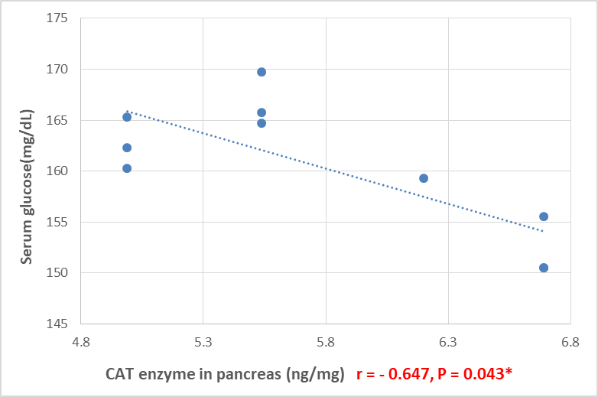

Figure 1: Spearman correlation of serum glucose with pancreatic CAT enzyme in the high-dose group.

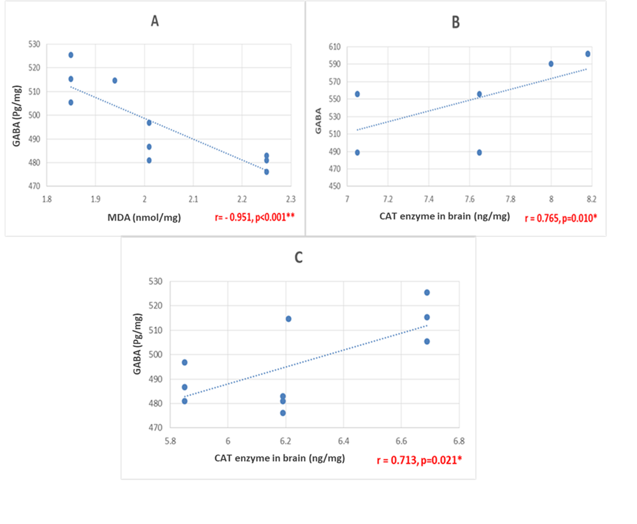

Figure 2: Spearman correlation between: A) GABA and MDA in brain of the high-dose group. B) GABA and CAT in brain of the low-dose group. C) GABA and CAT in brain of the high-dose group.

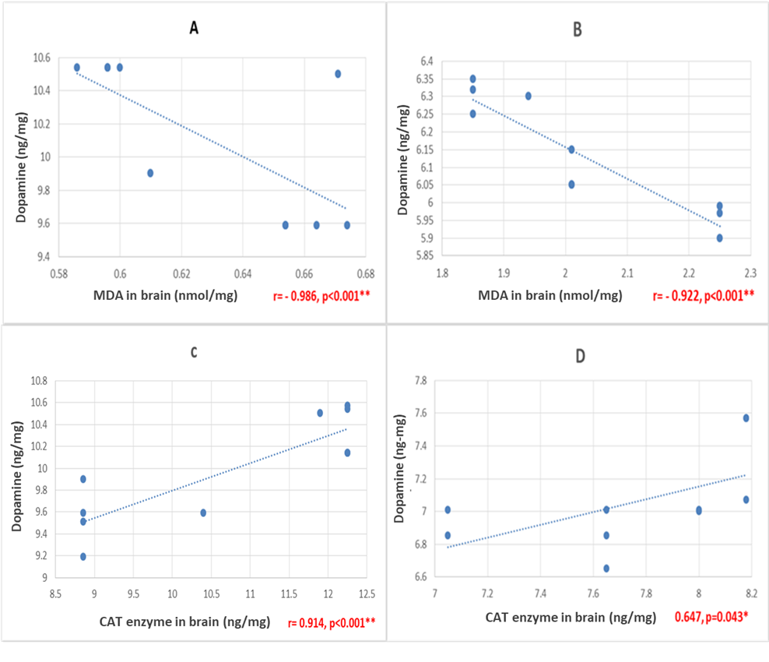
Figure 3: Show spearman correlation between: (A) Dopamine and MDA in brain of the control group. (B) Dopamine and MDA in brain of the high-dose group. (C) Dopamine and CAT in brain of the control group. (D) Dopamine and CAT in brain of the low-dose group.

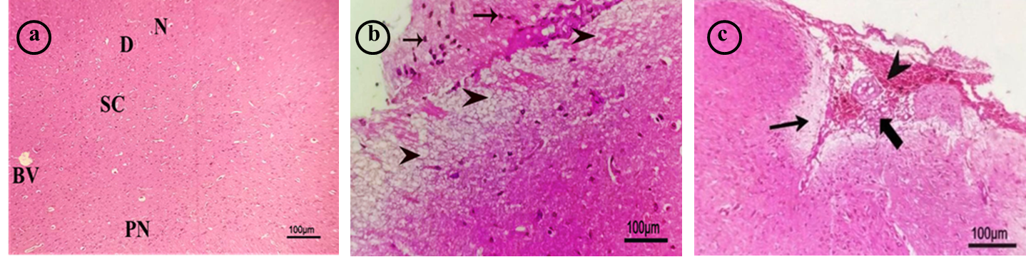

Figure 4: Photomicrographs of the cerebral cortex (scale bar = 100 µm). (a) Control group showing normal parenchyma, subcortical white matter (SC), dendrites (D), intact neurons (N), pyramidal neurons (PN), and blood vessels (BV); (b) low-dose ED group showing massive focal spongiform degenerative changes (neuronal vacuolation) (arrowhead) with demyelination of some neurons (arrows); (c) high-dose ED group showing perivascular encephalomalacia (thin arrow) with hemorrhage (arrowhead) and spongiform degeneration of some neurons (thick arrow).

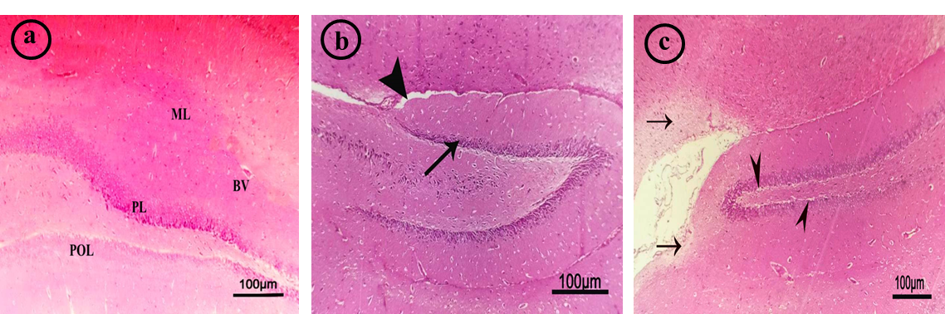
Figure 5: Photomicrographs of the hippocampus (scale bar = 100 µm). (a) Control group showing normal histological structure of parenchyma with normal pyramidal layer (PL), polymorphic layer (POL), and molecular layer (ML) with normal blood vessels (BV); (b) low-dose ED group showing mild reduction of in pyramidal cell density (arrow) with mild interstitial edema (arrow head); (c) high-dose ED group showing focal encephalomalacia (arrows) with focal spongiform degenerative changes (neuronal vacuolations) of some neurons (arrowhead).
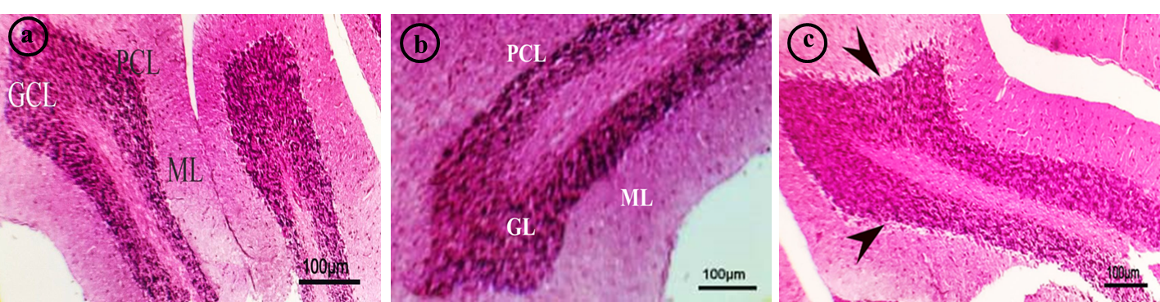
Figure 6: Photomicrographs of the cerebellum (scale bar = 100 µm). (a) Control group showing normal histological structure of parenchyma with normal granular cell layer (GCL), purkinje cell layer (PCL), and molecular layer (ML); (b) low-dose ED group showing normal granular cell layer (GCL), purkinje cell layer (PCL), and molecular layer (ML); (c) high-dose ED group showing focal spongiform degenerative changes (neuronal vacuolation) (arrowhead).

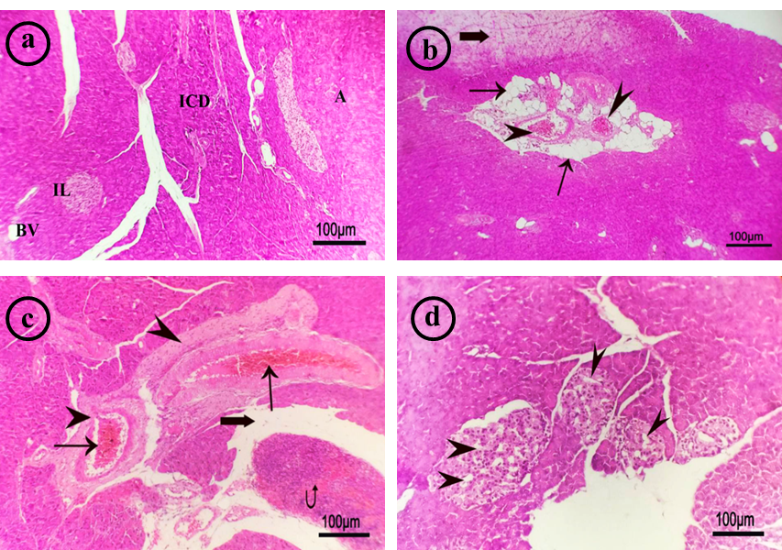

Figure 7: Photomicrographs of the pancreas (scale bar = 100 µm). (a) Control group showing normal pancreatic acini (A), intercalated ducts (ICD) with normal islets of Langerhans (IL) and blood vessels (BV); (b) low-dose ED group showing vascular congestion (arrowhead) with perivascular steatosis (fatty degeneration) (thin arrows) small focal necrotic area is observed (thick arrow); (c) high-dose ED group showing severe vascular congestion (thin arrows) with perivascular fibrosis (arrowhead), hemorrhage (curved arrow), and peri vascular edema (thick arrow) (d) high-dose ED group showing
partial necrosis of the islets of Langerhans (arrowhead).

تأثيرات استهلاك مشروبات الطاقة على مخ وبنكرياس ذكور الفئران البيضاء البالغة: دراسة كيميائية حيوية وهستوباثولوجية
أميرة محمد سمير محمد، عبير عبد الوهاب شرف الدين، مها محمد مختار، مروة محمد مراد، نهى سليمان النجار
قسم الطب الشرعي والسموم الاكلينيكية، كلية الطب، جامعة بنها، بنها، مصر
الملخص العربي
المقدمة : شهدت السنوات الأخيرة زيادة ملحوظة في استهلاك مشروبات الطاقة، لا سيما بين فئة الشباب والمراهقين، تصنف مشروبات الطاقة على أنها مشروبات غازية غير كحولية تحتوي على نسب مرتفعة من الكافيين والتورين والكربوهيدرات، بالإضافة إلى الفيتامينات والمستخلصات العشبية مثل الجوارانا والجينسنغ. يؤدي الإفراط في تناول مشروبات الطاقة إلي آثار صحية متعددة، لاسيما على الجهاز العصبي، إلى جانب اضطرابات القلب والجهاز الهضمي، ومشاكل الدم، وأمراض الكلى والكبد والبنكرياس. كما يزيد من خطر الإصابة بالسمنة وداء السكري ومتلازمة التمثيل الغذائي. هدف البحث: هدفت هذه الدراسة إلى تقييم التأثيرات الضارة المحتملة لأحد مشروبات الطاقة الشائعة في مصر على كلٍ من المخ والبنكرياس في ذكور الجرذان البيضاء البالغة. وقد تم ذلك من خلال التقييم البيوكيميائي لمستويات الجلوكوز، ومؤشرات الإجهاد التأكسدي، والناقلات العصبية، بالإضافة إلي الفحص الهستوباثولوجي لأنسجة المخ والبنكرياس. طريقة البحث: تم تنفيذ هذة الدراسة علي ثلاثون من الجرذان البيضاء البالغة وتم توزيعها إلي ثلاث مجموعات بصورة عشوائية، حيث تتكون كل مجموعة من عشر جرذان. تم اعطاؤهم مياة، مشروب فولت بجرعة منخفضة (3,1 مل/100جم يوميًا)، وأخري بجرعة عالية (6,3 مل /100جم يوميآ) علي التوالي عن طريق الفم لمدة أربعة أسابيع. النتائج: أظهرت نتائجنا فيما يخص التأثيرات المصاحبة لمشروبات الطاقة زيادة في مستوي سكر الدم و زيادة الإجهاد التأكسدي (ارتفاع المالونديالدهيد وانخفاض كاتالاز)، وانخفاض الناقلات العصبية (جابا والدوبامين). وقد دعمت هذه التغيرات الكيميائية الحيوية وجود تغيّرات نسيجية تتمثل في وجود تنكس عصبي، وارتشاح خلوي التهابي في المخ وأيضا وجود نخر، وتفتت نسيجي في البنكرياس. الخلاصة: تناول مشروبات الطاقة مصحوب بتأثيرات سمية علي كلا من مستوي السكر في الدم والنواقل العصبية وزيادة الإجهاد التأكسدي مع تغيرات هستوباثولوجية في كلا من المخ والبنكرياس.

